Preparations for the 12th „Night at the Institute of Aviation” have started
The largest night educational event in Poland for aviation, space and engineering enthusiasts prepares for another edition. The 12th "Night at the Institute of Aviation" will take place on Friday, October 6, 2023 at Łukasiewicz - Institute of Aviation in Warsaw. The organizers have already presented the official poster and trailer of the event.
"Night at the Institute of Aviation" is an event addressed to all those who are curious about the world and like to spend their free time actively.
– This year we celebrate the 500th anniversary of Nicolaus Copernicus which is why this year our poster refers to space. During the event we will present many interesting solutions, technologies and products – both for space and aviation. Night sightseeing will be combined with amazing attractions and meetings with interesting guests. It will be a special night for every science fan – says event manager, Magda Wiejacha.
The exhibition will be open from 5 pm till 11 pm. Entrance is free of charge.
Details about the event program will be published on the organizer's channels:
https://www.facebook.com/nocwinstytucielotnictwa/
www.nocwinstytucielotnictwa.pl
www.ilot.lukasiewicz.gov.pl

Official trailer of the event:
https://www.youtube.com/watch?v=MEGSgWQQdyA

About the event:
"Night at the Institute of Aviation" is the largest night educational event in Poland, the aim of which is to popularize the aviation and space sector and to promote engineering professions.
Every year the number of visitors and the interest of the media are growing. In the previous, eleventh edition, the Institute was visited by over 58,000 people in just 6 hours. In total, over 360,000 people have visited the Institute so far.
Apart from the static exhibition presented outside, numerous accompanying events are planned.
Visitors will also be able to access laboratories that are not available on a daily basis. This only night of the year will be a rare opportunity to visit Łukasiewicz – Institute of Aviation in Warsaw.

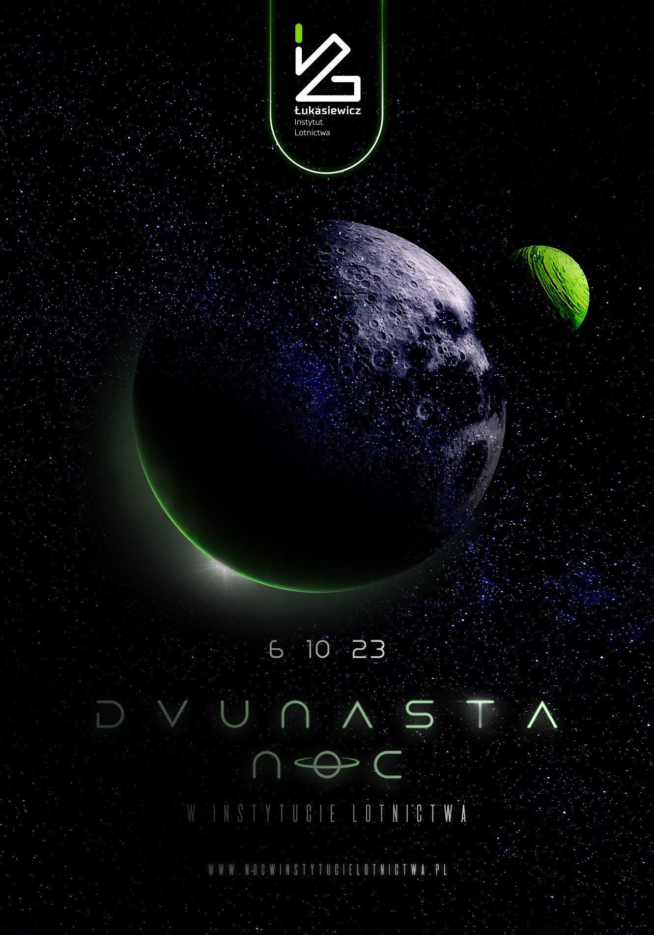
Official poster of the Night at the Institute of Aviation.

